Battlegroup: 1985

**Introduction:**

Battlegroup: 1985 is a fan made theatre for the Battlegroup system set in 1985. It is designed with a WW3 in Europe setting in mind, specifically a Soviet invasion of Western Europe such as those posited in Tom Clancy’s *Red Storm Rising*, General Hackett’s *The Third World War* and several other novels and alternative histories.

A number of changes to the rules have been necessary, mainly in the form of additions, but the most all-encompassing change is to ammunition limits.

Modern armoured vehicles generally carry substantially more ammunition for their main weapons than their WW2 equivalents did (this is especially true of the larger NATO MBTs). Weapon systems also tend to be more accurate, meaning that fewer rounds are required to destroy a target, and there has been a serious proliferation of ammunition types being carried.

Putting realistic numbers on the ammunition supplies of different types of ammunition in most MBTs in play testing resulted in games where the book keeping was extremely fiddly. Additionally this usually turned out to be pointless. The totals were so high that the chances of running out of a type of shell were quite low, and even then you usually had a similar enough shell to get the job done to some degree. As a result, most weapon systems in BG:1985 have unlimited ammunition.

The exception to this is guided missiles, which in 1985 were both expensive and only available in limited numbers – at least compared to the number of targets for them.

In BG:1985 guided missiles have limited ammunition both when mounted on vehicles and when carried by infantry. Most other weapons have unlimited ammunition, except in cases where they were noted for having issues with rapidly running out of ammunition (such as the ZSU-23 and the Gepard).

**General Rule Changes:**

Damage to transported troops

*This change has now been rendered irrelevant by an FAQ. When a transport is destroyed there are d3 casualties total, spread between the transported units as determined by the owner of the transport.*

Disembarking Troops

Modern wheeled APCs are capable of moving at high speed on roads, but still need to slow down to reasonable speeds to disembark troops (also, allowing full speed move/disembarks for some of these vehicles simply breaks many scenarios).

*A transport vehicle (other than a helicopter) which disembarks infantry after moving as a single activation may move a maximum of 12” during that activation.*

Area Fire against Lightly Armoured Vehicles

Open topped vehicles are now something of a rarity on the battlefield, however many fully enclosed vehicles have such thin side armour that they are much more vulnerable to shell fragments and HMG fire than other enclosed vehicles.

*A fully enclosed AFV with side armour of ‘O’ is treated as an open topped vehicle when being targeted by Area Fire by any weapon with an armour penetration value (i.e. anything except Small Arms and standard MGs).*

Aimed Fire at Aircraft

*It is possible to conduct Aimed Fire against Helicopters flying at Contour and Nap of the Earth altitudes with all Small Arms, MGs, Autocannons and Guided Missiles. A helicopter which has moved imposes a -2 penalty to hit rather than a -1 penalty (except for Guided Missiles, which only suffer a -1 penalty).*

*Fixed wing aircraft and helicopters flying at High altitude can only be targeted by Aimed Fire from guided missiles with the SAM attribute, guns mounted on other aircraft, and guns with the AAA attribute.*

*When using Aimed Fire against aircraft of any type at any altitude, rate of fire is reduced as follows:*

|  |  |
| --- | --- |
| Weapon | RoF when using Aimed Fire against Aircraft |
| Assault Rifle | 1 |
| Light MG/Tank MG | 1 |
| Medium MG | 2 |
| Heavy MG | 3 |
| Pintle Mount MG | 2 |
| Lt. Autocannon | 3 |
| Hvy Autocannon | 4 |
| Multi Lt. Autocannons | 5 |
| Multi Hvy Autocannons | 6 |
| Minigun | 5 |
| Rotary Cannon | 6 |
| Guided Missiles | *Unchanged* |

**New Unit Types and Attributes:**

Helicopters

The few helicopters that featured in WW2 were an oddity, but it is a weapon platform and transport that has since come of age. Able to operate more closely with ground forces than fixed wing aircraft, yet still able to have many of their advantages, helicopters are more typically assigned to formations rather than called in for single strikes.

*Helicopters do not use the aircraft rules (unless flying at High Altitude – see below). Instead they operate as vehicle units with the following differences:*

Altitude

When a helicopter is deployed or moves, an altitude is specified for it. It will remain at this altitude until its next movement action (or until destroyed). The altitudes available are:

|  |  |  |
| --- | --- | --- |
| Altitude | Description | Effects |
| Nap Of the Earth | The helicopter flies extremely low – within just a few feet of the ground where possible, dodging around and behind obstacles as needed. This kind of flying is quite difficult.  This altitude cannot be maintained over tall terrain such as trees or buildings. If the helo cannot go around such obstacles it may go over them, but if a unit ambush fires at that point the helo is considered to be at contour altitude. | Line of site and cover are determined as if the helicopter were on the ground.  The helicopter suffers a -1 penalty to observe targets.  The helicopter’s NOE speed is used. If it has none, then it is unsuited for such manoeuvres and cannot fly at this altitude. |
| Contour | The helicopter flies just above the height of any nearby obstacles. This kind of flying is still difficult, but is possible for all helicopters. | Line of sight and cover are determined as if the helicopter were 4” above the ground (from its underneath) or just high enough to clear any obstacle within 12”, whichever is higher.  The helicopter’s Treetop speed is used. |
| High  (Low Level) | The helicopter flies well above the terrain but still quite low.  (The official term for this altitude comes from a system used for all aircraft, but it proved too confusing in practice.) | The helicopter is treated as a normal aircraft for the purposes of shooting or being shot at.  The helicopter receives a +2 bonus to observe targets.  The helicopter’s speed is effectively infinite.  The helicopter is treated as being at 20”-30” range for the purposes of being shot at. |

* A helicopter’s altitude must be clearly indicated (e.g. by stands of different heights, by a token, or in any other way that is mutually agreeable).
* A helicopter can land by using the appropriate order, though the spot where it lands must be large enough to accommodate the vehicle (and its rotor disc). Whilst landed it is treated as a ground vehicle. If you wish to disembark troops from a helicopter it must start its activation landed, unless using the Rappel order.
* All helicopters are considered to be soft skin vehicles.

Unit Attributes:

Amphibious

The Soviet Army in particular demanded that most of its vehicles be capable of crossing bodies of water on their own, whether by swimming over them or driving along the bottom. This feature was also popular in other armies – especially for reconnaissance vehicles.

*A unit with this rule can cross water at the speed listed in its special movement column. Both players may agree before the game that a particular body of water on the table cannot be crossed in this way.*

Challenging NoE (Helicopters only)

After experiences in Afghanistan facing handheld SAMs, Soviet helicopter units were forced to change their tactics and adopt NoE altitudes. Unfortunately for the aircrew, the Hind had not been designed with such flight envelopes in mind and proved to be quite tricky, if not downright dangerous[1], to use in such a manner.

*A unit with the Challenging NoE property must take a Unit Experience Test when moving at NoE altitude. If it fails the test then it is forced back to Contour altitude during this move and a second test must be made. If the second test fails then the unit takes a single hit.*

Designated Marksman

Designated marksmen are sort of, but not exactly snipers. They are members of an infantry squad who are typically armed with semi-automatic rifles equipped with telescopic or other long-ranged sights. Their job is to provide their squad with the ability to lay down effective fire at long ranges – up to 1000 m.

*Small Arms issued to Designated Marksmen have a range of 40” and use the same Hit Values as Machine Guns.*

Fast Jet

Many modern CAS aircraft are much faster than WW2 aircraft could hope to be. This makes them much harder targets for AAA.

*Aimed and Area fire at Fast Jets must re-roll successful hits unless the weapon being used is a guided missile, or it has the Radar property. The Radar property does not give re-rolls when shooting at Fast Jets (effectively the re-roll from Radar is cancelled by the re-roll from Fast Jet).*

Fire Teams

By 1985 western doctrines tended to emphasise breaking up squads into fire teams of 3-5 men.

*A unit with the Fire Teams rule may be deployed as a single unit or may break up into fire teams as indicated in its unit entry. Additionally, if deployed as a single squad it may be ordered to split into Fire Teams as part of any order involving movement (activate the models that will make up one of the teams and move them away, this does not count as activating the other team).*

*Until reunited, each team counts as a separate unit for all purposes. Fire teams can be reunited with the Reform order.*

Hardened

Some aircraft have more armour than others. Whilst it remains impossible to make a helicopter or airplane truly immune to small calibre ammunition without losing the ability to fly, armouring all key points can certainly make them more durable against these.

*When using Aimed Fire from small arms, light and medium machineguns against a helicopter with the Hardened attribute, re-roll successful hits. All other weapons ignore this attribute.*

Thermal Imaging/Advanced Optics

Thermal Imaging systems translate radiant infra-red heat into visible light, allowing the user to see the heat coming from enemy vehicles, weapons and even soldiers. This makes target acquisition easier.

Advanced Optics are systems which may or may not actually include a thermal imaging system, but which are effective enough to have the same effect in game.

*A unit with Thermal Imaging or Advanced Optics may re-roll its first attempt to acquire a target.*

**New and Adjusted Weapons:**

A number of new types of weapons have been developed since the end of WW2, and others have changed markedly in effect.

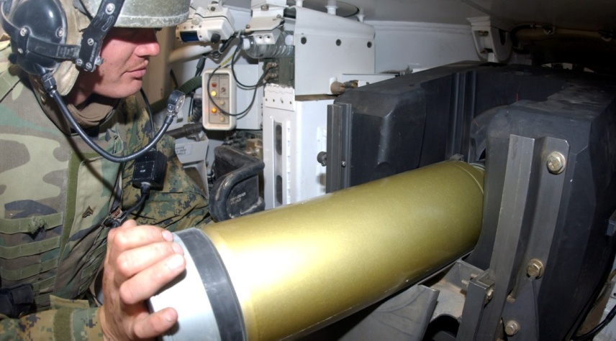

High Velocity Cannons

Typically mounted on main battle tanks, modern high velocity cannons are markedly more effective than WW2 era guns in terms of accuracy and range. This is primarily due to higher muzzle velocities, heavier and more stable ammunition, and finer manufacturing tolerances.

Some High Velocity Cannons can fire Guided Missiles. When doing this, use the rules for Guided Missiles below.

*High Velocity Cannons have a maximum range of 70”.*

Advanced High Velocity Cannons

Applying computing technology and other advances to the firing of High Velocity Cannons yielded increases in both accuracy and effective range.

*Advanced High Velocity Cannons have a maximum range of 90”.*

Cluster Bomb (X)

Cluster Bombs were very much in their infancy during WW2, but have become very powerful weapons.

*Cluster Bombs are handled as per normal bombs with some exceptions. Firstly, the diameter of the area in which units can be hit is X” (default 10”). Secondly, instead of generating 2 shots per bomb they generate one per unit in the area.*

*Cluster Bombs always attack rear (actually top) armour on vehicles and count as Heavy HE for pinning.*

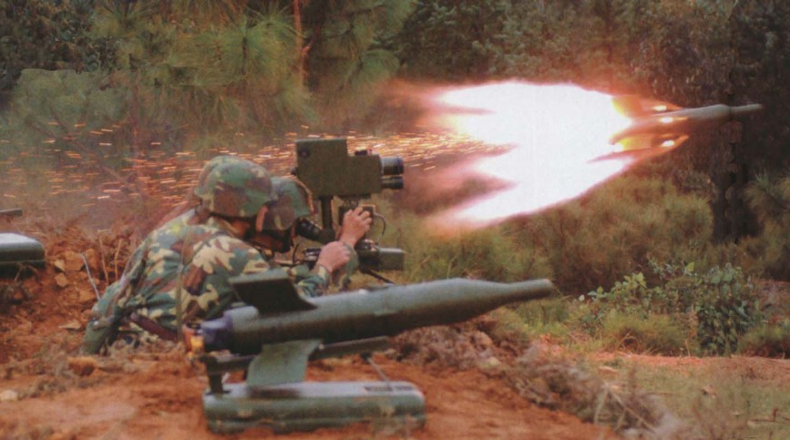

Guided Missiles

The earliest guided missiles were used during WW2, but were neither decisive nor widely used weapons. Since then, guided missiles have come of age.

Guided missiles operate quite differently from most other weapons. When launched they must accelerate to their operational speed, they move quite slowly compared to other weapons, and their guidance systems are subject to their own limitations.

There are different methods of guiding missiles. See the new orders “Lock On and Fire” and “Fire and Guide” for details – these are the only orders which can be used to shoot these weapons.

*Unless otherwise noted, guided missiles have a maximum range of 90”. Guided missiles carried by infantry teams have a total ammunition load of 1 missile for the gunner and 2 for each other member of the team unless otherwise noted in the unit description.*

*Guided missiles ignore the modifier for a moving target (unless shooting at a helicopter or fixed-wing aircraft) and cannot be used for Area Fire.*

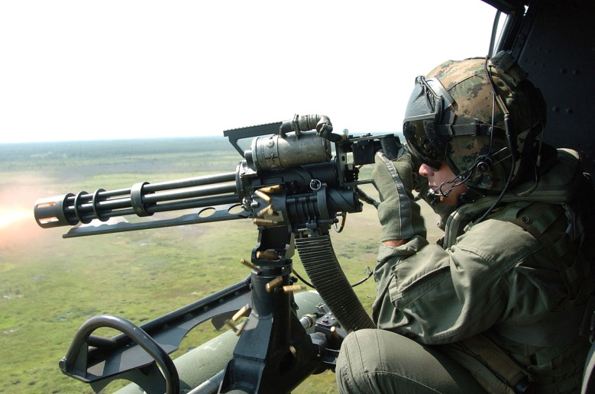

Miniguns and Rotary Cannons

Whilst multiple barrelled Gatling guns predate WW2 by decades, they fell out of favour with the development of the proper machinegun and did not return to the battlefield until the deployment of modern miniguns and rotary cannons during the 1960s.

Both styles of weapon use multiple, rotating barrels to achieve a very high rate of fire. Typically miniguns use rifle calibre or similar ammunition, whilst rotary cannons use autocannon shells.

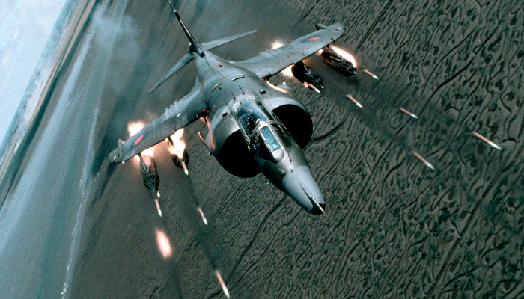Rocket Pods

Rocket pods are the successors of the individual, unguided rockets of WW2. They now come in pods of multiple rockets (individually smaller than most WW2 versions), and can be significantly more accurate (though not always).

Some rocket pods are designed to salvo all their rockets in one shot, whilst others use ripple firing of small numbers of rockets. Some pods allow both modes of operation.

*A Rocket Pod fired as a Salvo is a single use weapon. It is treated as indirect fire with a few differences:*

* *Rocket pods cannot be called in like artillery or mortars – only the unit with the weapon can fire it.*
* *The target point for the Ranging Shot must be visible to the firing unit. It must be more than 10” from the firing unit.*
* *For helicopters only: when rolling for scattering, a roll of 1 indicates scattering 2d6 in a random direction – any other roll does not scatter.*
* *For aircraft only: use the aircraft’s Bombing Computer rating for scattering as with unguided bombs.*
* *Once a Ranging Shot is made the attack cannot be aborted.*
* *The number of shots in the strike is indicated in the weapon’s stat line, e.g. Salvo(5) for 5 total shots. This number is for a pair of rocket pods firing (as they are almost always fired in pairs).*
* *The radius of effect varies depending on the distance to the target from the firing unit:*
  + *0-30” (or any shot from an aircraft): 10” radius*
  + *30”+: 15” radius*

*A Rocket Pod using ripple fire is treated like any other HE weapon, although it suffers a -1 to hit with Aimed Fire (as usual, a 6 always hits). A unit with a Rocket Pod which is capable of both types of firing must choose which type of fire it will use for the game when it first fires the weapon.*

*Rocket Pods cannot be reloaded during the game.*

|  |  |  |  |  |
| --- | --- | --- | --- | --- |
| **Weapon** | **RoF** | **Range** | **Crew** | **Notes** |
| *Small Arms* |  |  |  |  |
| SMG | 1 | 10” | - | RoF 2 in close assault |
| Battle Rifle | 2 | 30” | - | RoF 1 in close assault |
| Assault Rifle | 2 | 30” | - | RoF 1 beyond 20” |
| LMG | 3 | 40” | - |  |
| SAW | 5 | 40” | 2 |  |
| Pintle Mounted MG | 5 | 40” | - |  |
| GPMG Bipod | 6 | 40” | 2 |  |
| GPMG Tripod | 8 | 40” | 2 |  |
| Heavy MG | 6 | 40” | 3 |  |
| AFV MG | 3 | 40” | - |  |
| Grenade Launcher | - | 30” | - | Very Light HE (3/5+) |
| AGL | - | 50” | 2 | 2 x Very Light HE (3/5+) |
|  |  |  |  |  |
| *Man Portable Missiles* |  |  |  |  |
| RPG/LAW | 1 | 15” | - | Very Light HE (3/5+) |
| MAW/Rocket Launcher | 1 | 20” | 2 | Light HE (4/4+) |
| ATGM | 1 | 90” | 2 |  |
|  |  |  |  |  |
| *Heavy Guns* |  |  |  |  |
| Light Autocannon | 6 | 50” | 2 | Also counts as Light HE |
| Multiple Light Autocannons | 10 | 50” | 3 | Also counts as Light HE |
| Heavy Autocannon | 8 | 50” | 3 | Also counts as Light HE |
| Multiple Heavy Autocannons | 12 | 50” | 4 | Also counts as Light HE |
| Minigun | 10 | 40” |  |  |
| Rotary Cannon | 10 | 50” |  | Also counts as Light HE |

*Note that the values in this table are default values. Some weapons will have differing values which will be noted in their entries.*

Weapon Attributes:

*AAA/SAM*

Weapons with the AAA or SAM attribute can use Aimed Fire against aircraft. Weapons with the SAM attribute can only be fired at aircraft.

When using Aimed Fire against aircraft, the target is treated as being in the 20-30” range bracket.

*Advanced Fire Control*

Some fire control systems are better than others. Weapons with the Advanced Fire Control attribute do not suffer a -1 penalty when shooting at a moving target.

*Beyond Visual Range (BVR)*

A number of air defence weapons have the capability to engage enemies from beyond the distance at which they can be seen.

*See the Aircraft rules for the effects of BVR.*

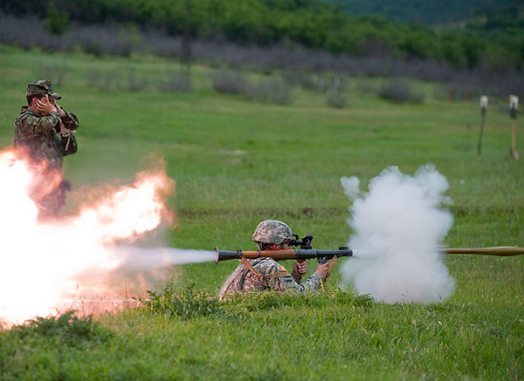

*Back Blast*

Weapons with the Back Blast quality cannot be fired from enclosed spaces. Teams attempting to observe another team which fired a weapon with Back Blast gain an additional +1 on the roll.

*Dismountable (X) [I]*

A number of vehicles, particularly IFVs and APCs, have weapons that are designed to be easily dismounted to be used on foot by infantry.

*A weapon with the dismountable characteristic can be removed from the vehicle and given to X infantry, who may either form a new team or stay within their existing team. The weapon retains whatever ammunition level it had before being dismounted.*

*Some vehicles with dismountable weapons are independent units themselves, in which case some of the crew will dismount with the weapon. These vehicles’ entries are marked with an ‘I’ to denote this. Otherwise the infantry needed to operate the weapon must come from another unit (usually one transported in the vehicle).*

*Dismounting can be done as part of a Disembark order, in which case the weapon must come from the vehicle being disembarked from.*

*Alternatively, an infantry squad may use the Dismount Weapon order to do the same thing. The squad may make a normal move, but must be able to come within 5” of the vehicle. The vehicle may not have moved during this turn, although it can later be activated and moved as normal.*

*HEAT, DP*

These weapons utilise the Munroe Effect, more commonly known as a Shaped Charge. As this type of weapon has become increasingly common for anti-tank weapons, tank designers have adapted armour to be more effective against them.

HEAT weapons are specialised in the anti-tank role. They can be quite effective against infantry in buildings or bunkers, but they have almost no effect against infantry in the open unless they have been specifically designed as Dual Purpose (DP) weapons. They do go off with a very impressive bang however, and have been known to cause units to panic and/or surrender.

HEAT warheads on ATGMs are quite effective against helicopters, and this is indeed a designed secondary role for many ATGMs.

*A weapon with the HEAT characteristic tests against the target’s Armour vs HEAT rating (in brackets) if present. Otherwise it tests against armour as normal.*

*A weapon with the HEAT characteristic can only use its HE value against infantry if they are inside an enclosed structure or trench, or if the weapon has the DP keyword. It can still be fired at infantry in the open, in which case a hit will force a morale test as if the unit had taken a casualty.*

*A weapon with HEAT uses its HE value against helicopters in the same way as other HE shells.*

*Inaccurate (-X)/Accurate (+X)*

Some weapons are inherently more or less accurate than others – especially amongst anti-aircraft weapons. Additionally, some weapons are more or less accurate against certain types of targets (especially command guided missiles vs slow or fast moving targets).

*When using aimed fire, inaccurate weapons suffer a –X penalty and accurate weapons gain a +X bonus. If a type is indicated then this property only affects shots fired against that type of target.*

*Radar*

A number of anti-aircraft systems utilise radar guidance. For AAA this makes them much more accurate against aircraft (for missiles this accuracy is accounted for already). An active radar can be detected with the right equipment however, and can even be homed in on by anti-radiation missiles.

*An autocannon with the Radar property may re-roll misses when using Aimed Fire against Helicopters flying at NoE or Contour altitude. It may use the Guided Missile column when using Aimed Fire against fixed wing aircraft and helicopters flying at Low altitude.*

*Revenge Missile*

Before the 1980s infrared guided SAMs (and air to air missiles) could only target very hot targets such as the exhaust of a jet or turbine engine. Whilst lock-on was achievable against a head-on target with some missiles, this was only possible at very close ranges.

Whilst a fighter aircraft can manoeuvre behind its target this is not an option for ground-based weapons, whose operators would typically be unable to get a lock until after the aircraft had already fired its weapons. For this reason they were often called revenge or vengeance missiles.

*When using Reserve Fire, a weapon with the Revenge Missile attribute cannot prevent an attack from a fixed wing aircraft, even if the aircraft is destroyed.*

*Stabiliser*

Modern weapon stabilisers are incredibly effective, although still not as good as shooting whilst staying still – even the best stabiliser can be momentarily disrupted by an unexpected dip in the road.

*Weapons with the Stabiliser attribute suffer no penalty for firing before or after moving and may use the “Fire, Move, Fire” order.*

*Swingfire*

The Swingfire ATGM missile is unique in that it is designed to turn up to 90 degrees immediately after firing, allowing the launcher to be hidden and the operator to guide it from a more advantageous position.

*The operator of a Swingfire can disembark from the vehicle (place a single figure up to 5” away from the vehicle). As long as the target is within the 180 degree frontal arc of the launcher and there is an appropriate path for the missile to take, line of sight for an attack can be drawn from the operator.*

*Whilst the operator is disembarked in this manner he is vulnerable. If he becomes pinned then the vehicle cannot fire its Swingfire system until he is either unpinned or removed from the table (despite being pinned, he can still be given an order to return to the vehicle). If he is killed then the vehicle may still use its Swingfire system, but may not disembark another operator.*

*Wire Guided*

Many (though not all) ATGMs are controlled by electronic signals sent down a wire from the operator to the missile. Without the commands from the wire, the missile cannot be guided in its flight[2].

Wire spools out behind the missile as it flies, and can become entangled in obstacles – almost invariably causing it to break. Groups of trees and brush are particularly good at snagging wires from ATGMs and operators are instructed not to fire through such obstacles.

*Wire guided weapons cannot be fired from within or across woods – although a unit at the edge of a wood may fire out. If the firing team is able to move, then at no point during that move may the line between the team and the target cross woods.*

**New and Modified Orders:**

Lock On and Fire

This order is used to fire missiles that do not have the SACLOS or MCLOS characteristics. These missiles are self guiding, usually utilising Infrared or Radar systems which must be locked on to a target prior to launching. They cannot be used for Area Fire.

The firing team identifies a target with an observation roll in the same way as for aimed fire with small arms. It then fires the weapon.

*Teams cannot move as a part of this order unless they are aircraft and they may only fire once per order. If a team becomes pinned or is hit during this order then the shot automatically misses.*

*Aircraft and helicopters may move at their normal speed during this order, but fixed wing aircraft may only move directly towards the target. Helicopters may move in any direction they wish (at reverse speed if not moving directly forwards) but must remain pointing straight at the target – the missile is considered to be launched from the aircraft’s starting position for the purposes of facing, cover, etc.*

Fire and Guide

This order is used to fire missiles that have the SACLOS or MCLOS characteristics. These missiles are guided by the firing team from the launch until impact, and any interruption to this process will result in a miss.

The firing team identifies a target with an observation roll in the same way as for aimed fire with small arms. It then fires the weapon and stays still, guiding it.

*Teams cannot move as a part of this order unless they are aircraft and they may only fire once per order. If a team becomes pinned or is hit during this order then the shot automatically misses.*

*Aircraft and helicopters may move at their normal speed during this order, but fixed wing aircraft may only move directly towards the target. Helicopters may move in any direction they wish (at reverse speed if not moving directly forwards) but must remain pointing straight at the target – the missile is considered to be launched from the aircraft’s starting position for the purposes of facing, cover, etc.*

Fire, Move, Fire – *Stabiliser required*

This order may only be used when firing weapons with the Stabiliser attribute. The unit fires once before moving and then once more after moving, but both shots take a -1 penalty.

Rappel

Rappelling from a helicopter is a difficult skill, but one that can save a great deal of time during combat operations and also allows forces to land in terrain that prevents the helicopter from landing.

Rappelling is quite dangerous, with even elite troops facing the possibility of injury or even death when rappelling in combat conditions, but it does allow troops to be deployed into any terrain type.

Only troops with Veteran or Elite status may rappel. The helicopter must hover in place while the troops are placed underneath it. Each trooper placed must make a skill test – re-rolling successful tests if being placed in difficult or dangerous terrain. Remove one trooper as a casualty for each failed test (you may choose which models are removed), but no morale test is required.

Reform

Units that have separated into Fire Teams can be recombined by means of this order. The teams must be able to move into unit coherency with each other by means of 2 normal movements. The newly reformed unit counts as having received an order this turn.

Ambush Fire

Teams using Ambush Fire may respond with the Open Fire, Fire and Guide or Lock On and Fire orders.

Land/Take Off – *Helicopters only*

This order may only be used by helicopters. The vehicle may either land or take off, and may also take one movement action.

In order to land safely there must be a space large enough for the helicopter model to be placed and for the entire disc of the rotor to be clear of all obstacles. If there is an obstacle within 2” of either the model or the rotor disc then a successful skill test is required in order to land – if it is failed then the helicopter hovers in place instead.

**Fixed Wing Aircraft**

The struggle for control of the air over the frontlines was expected to be intense during any WW3 scenario. Both sides judged it extremely unlikely that it would be possible to establish true air superiority over the front in the way it had been achieved in conflicts with smaller powers and during WW2.

Swift Egress

An attacking pilot in hostile airspace will want to make a single attack and then leave, preferably as fast as possible. Once an attack has been made, roll a single d6. If you roll a 5+ the aircraft may be brought in for another run during the next turn, otherwise it is removed from play.

If the attacking aircraft has taken any damage it may not make this roll – it automatically leaves after making its attack.

Off-Table SAM Support

The Warsaw Pact in particular spent a great deal of time and effort developing a mobile, layered air defence system which was embedded in its ground forces. Whilst short ranged elements would be present at the frontlines, longer ranged missile launchers would do their work from several miles behind the lines.

NATO also had its own SAM belts, both mobile and less mobile.

*For each time an off-table SAM support option is bought you may make a single attack that can be used without an order, and which can be used to interrupt any activation by an opponent’s aircraft or helicopter.*

*Off-table SAM shots hit on different values depending on the altitude of the target. Line of Sight is not required and no modifier is applied for a moving target. An aircraft can gain concealment, imposing a -1 penalty to the hit roll, by ensuring that there is no line of sight between itself and the opponent’s table edge.*

*In order to use an off-table SAM shot, make a communications test. A failed communications test does not use up the shot, but does prevent you from using it until the next player’s turn.*

Combat Air Patrols

NATO forces, in particular US forces, focussed heavily on airborne fighters and interceptors to deny the airspace above the battlefield to their enemies. These aircraft would patrol well behind the lines, moving forward at the behest of air controllers to engage targets as they appeared.

The Warsaw Pact also had fighters and interceptors to call upon.

*For each time a Combat Air Patrol is purchased you may call in an attack by a single fighter from off-table. This attack can be used without an order, and can be used to interrupt any activation by an opponent’s aircraft or helicopter.*

*The fighter will make a single attack with each of its weapon systems, starting with any Beyond Visual Range (BVR) weapons, until it either destroys the enemy or runs out of weapons. The fighter can be interrupted during these attacks as usual, but BVR attacks can only be interrupted by other BVR attacks – if you do not have any of these available you must wait until the fighter has finished its BVR attacks to interrupt it (you can still interrupt the fighter even if it only made BVR attacks).*

*Combat Air Patrol attacks are HE shots[3] which hit on different values depending on the altitude of the target. No modifier is applied for a moving target.*

*In order to use a CAP attack, make a communications test. A failed communications test does not use up the attack, but does prevent you from using it until the next player’s turn.*

Fly Between the Weeds!

NATO air forces in particular were convinced during the 1980s that ultra low level altitudes were the only defence against the kinds of air defences they expected to encounter[4]. Soviet experiences in Afghanistan resulted in similar conclusions.

Helicopter pilots in particular were trained to fly at extremely low altitudes, as shown in the section on helicopters.

*Off-table SAMs and the weapons on Combat Air Patrol fighters have different effects based on the altitude of the target. Helicopters can control their altitude (see the Helicopter section), whilst fixed wing aircraft will be at Contour Altitude unless they are engaging another aircraft with BVR weapons, in which case they will be at Low Altitude.*

Who Owns the Skies?

Although it was expected that air superiority over the entire frontline would not be possible in a WW3 scenario, localised air superiority in a key engagement was a goal for both sides.

*At the beginning of the game, add the points spent by each side on air and anti-air assets, including all units with the AAA and SAM attributes, and all fixed wing and helicopter assets (off-table assets are included).*

*If one side has spent more than 75 points more than the other on these assets they have local air superiority and their opponent must draw a battle chit (in the same way as when you are out-scouted).*

**Optional: Night Fighting**

Technologies to aid night fighting have proliferated since WW2. There are 3 general types, each with their own characteristics.

Active infrared systems use an infrared spotlight combined with goggles or sights which pick up the reflected light. Effective range depends on the system, but usually varies from several hundred metres for man portable systems to well over a kilometre for vehicle mounted systems. The spotlight is invisible to the unaided eye, but is readily visible to both image intensifiers and other users of active infrared systems[5].

Image intensifiers are very sensitive cameras that use the light already available, effectively amplifying it. The first generations of these required moonlight to function, but by 1985 image intensifiers could operate in all but absolute darkness. Image intensifiers do not give away their users, but vary in effectiveness depending on how much light is available[6].

Thermal imaging systems, also known as Forward Looking Infra-Red (FLIR), use cameras which are sensitive to the frequencies emitted by warm and hot objects. Thermal imaging systems were very new during 1985, and represented the best available technology for finding enemies on a battlefield. They operate in nearly all weathers, are not reliant on light levels, are very difficult to camouflage against, and can cut through smoke, fog and haze to some degree[7].

*Night Fighting Rules:*

*Before playing a game at night, roll for the illumination level:*

|  |  |  |  |
| --- | --- | --- | --- |
| *Dice Roll* | *Description* | *Unaided Vision* | *Image Intensifier Range* |
| *1* | *Near total darkness – a moonless night with heavy cloud cover.* | *10”* | *20”* |
| *2-5* | *“Normal” darkness – a night with scattered cloud cover, some stars and possibly some moonlight.* | *20”* | *50”* |
| *6* | *A bright, moonlit night.* | *30”* | *Unlimited* |

* *Area Fire is unaffected by night.*
* *All observation tests are at -1 at night.*
* *Units that fire at night give a +1 bonus to be observed*
* *Without a special rule to the contrary, units are assumed to be using Unaided Vision.*
* *When conducting Aimed Fire or Spotting for Indirect Fire, the unit has a maximum range as indicated above.*
* *Units with Active IR have a vision range of 50” when using that system. Whenever a unit uses its Active IR to attempt to spot a target, mark that unit.*
* *Units with Active IR, Image Intensifiers or Thermal Imaging have unlimited range when attempting to spot a target that used Active IR during this or the previous turn.*
* *Units with Thermal Imaging have a vision range of 70”.*
* *Vehicles with a searchlight may use a skill test to illuminate an area within 30” and in their line of sight. This can take place when the vehicle is activated, regardless of what order is given to it.*
  + *If the skill test is successful, mark the area illuminated. When attempting to spot units within 10” of this marker, treat them as if it is daylight.*
  + *Regardless of whether the skill test is successful, all observation tests against the vehicle will be automatically successful until its next activation and it can be spotted at any range.*

**Optional: NBC**

The threat of weapons of mass destruction on the cold war battlefield was a serious one. Whilst biological weapons and direct attacks by nuclear weapons are outside the scope of BG:1985, the effects of radiation from previous or nearby strikes and the use of chemical weapons can impact the battlefield profoundly (without destroying the game).

NBC suits of numerous varieties were issued to troops on both sides of the iron curtain. These provided quite a decent level[8] of protection against chemical and biological weapons, and limited protection against radiation, at the cost of making all actions harder, awkward and tiring – a common estimate was that soldiers in full NBC protection would be at 50% effectiveness at best.

Most AFVs expected to fight on the battlefield were also hardened against NBC weapons. When combined with the NBC suits worn by the crew, this provided effective protection against radiation as well as chemical and biological agents, albeit at the cost of reduced crew performance.

**Contamination State**

If you wish to use NBC conditions in your game, then before deployment, but after placing objectives, roll a single d6 to determine the current contamination state:

|  |  |
| --- | --- |
| *Roll* | *Contamination State* |
| *1* | *Confirmed Contamination*  *This is the real deal. All units start the game Suited Up and must remain so. Units without NBC protection may not be deployed.* |
| *2-5* | *Contamination Warning*  *Is it real? All units start the game Suited Up (including helicopters) and must remain so until an NBC Test confirms or dismisses the warning.* |
| *6* | *No Contamination.* |

**Contamination Battle Counter**

If a player pulls a Contamination Battle Counter then it is put aside until the end of the current turn. At the end of the turn, roll a d6 – on a 3+ a Contamination Warning is issued. All units must attempt to Suit Up as their next order – and must continue to do so until either they succeed or the warning is dismissed.

If any units have failed to Suit Up after each player has taken a complete turn then those units make an NBC Test the hard way – by being exposed to it.

**NBC Test**

When a Contamination Warning is in effect it may or may not mean that the battlefield is contaminated. You can test for real contamination either by issuing the NBC Test order to a unit equipped with NBC Testing Equipment, or by having a unit that is not Suited Up exposed to it.

When you test, roll a single d6 and consult the following table:

|  |  |
| --- | --- |
| *Roll* | *Contamination State* |
| *1* | *Heavy Radiation!*  *All units that are not Suited Up vehicles or being transported inside such vehicles take d6 casualties per turn for the rest of the game.[9]* |
| *2-4* | *Confirmed!*  *All infantry units that are not Suited Up take d6 casualties per turn for the rest of the game.   Vehicles that are not Suited Up roll a d6 at the start of each turn. On a 4+ the vehicle is abandoned (the crew either dead or having fled).* |
| *5-6* | *All Clear!*  *The Contamination Warning is dismissed.* |

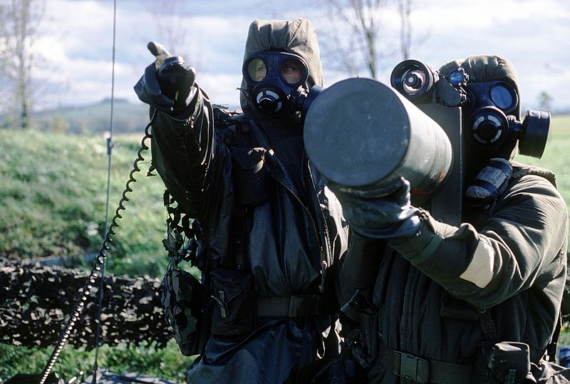

**Suit Up!**

Units ordered to Suit Up! spend their activation getting into their protective equipment and activating any necessary gear if they are in a vehicle. Make an experience test. Success indicates that the unit has Suited Up, whereas failure indicates that they are still struggling with the bulky equipment.

A unit that is Suited Up can fight on, albeit with penalties. Suited Up units suffer -1 to hit with Aimed Fire and -1 to all Observation tests. Infantry units reduce their movement speed to 3”.

*Instead of suiting up a unit can instead be ordered off the table by means of a normal movement order. If the unit reaches the edge of the table it is removed from play without a battle counter needing to be taken.*

*Alternatively, if an NBC Test has not yet happened, an infantry unit may be ordered to embark on a transport that has the NBC attribute[10].*

*Units which come onto the table while the battlefield is contaminated are automatically Suited Up. This includes units disembarking from a transport that is already Suited Up.*

Aircraft

Aircraft cannot receive the Suit Up! Order at all. Aircraft with the NBC rule are automatically protected against all NBC effects and can operate as normal (as they effectively suited up before taking off).

Aircraft without the NBC rule can only fly safely at Low Altitude. If, for any reason, they Land or fly at NoE or Contour Altitude then they are subject to the effects of the NBC threat like any other unprotected unit.

**Vehicle NBC**

Some vehicles are fitted with NBC protection systems that allow their crew to fight in a protected environment without NBC suits.

Vehicles with the NBC attribute automatically pass the Suit Up! experience test, and do not suffer the penalty to hitting with Aimed Fire – they still suffer the penalty to Observation tests, reflecting the need for the commander to button up.

Vehicles with the NBC trait still need to receive the Suit Up! Order to become Suited Up.

1. Hinds were damaged when they exceeded design tolerances, struck obstacles, and sometimes when their own rotors struck parts of the helicopter.
2. Exactly what happens to an ATGM when its wire is broken differs from model to model – many begin manoeuvring at random in response to the fluctuating voltage in the severed wire.
3. Cannon attacks are treated as HE in this case.
4. During Operation Desert Storm this approach may have resulted in increased casualties from AAA and MANPAD fire, however it did provide significant benefits against longer ranged missiles and ground-based radar intercept systems. Low-level attacks were abandoned by the USAF once they had attained air superiority, but the RAF kept its Tornados down in the weeds. The effect this had on RAF casualties is still being debated.
5. Thermal imagers typically operate on other frequencies and will not show IR spotlights, however vehicles with thermal imagers almost invariably also have image intensifiers.
6. Image intensifiers do not work in total darkness but, barring underground combat, this is unlikely to apply in BG.
7. They were also, naturally, quite expensive.
8. How long this might have lasted is another issue. Filters needed replacing very quickly (less than a day for the best ones, less than an hour for the worst) and it was not possible to eat or relieve oneself without being exposed to contamination.
9. Standard battlefield NBC Suits offer very little protection against heavy radiation.
10. Contaminated troops entering a protected vehicle would expose everyone in the vehicle to the contamination.